
DATA STRUCTURES AND ALGORITHMS (APT 2060A)
Group 3
Group Members
Irakoze Davy Franck-671730
Aleke James –669116
Angela Irungu- 669289
David Kamau – 669998
Idhil Hassan 671389

Submitted to
Dr.Ndirangu Dalton
On 28th May 2025

Group Work Assignment2 (20 marks)
Question 1:
- Define the term Array
- What is the major difference between an array and a variable?
- Why do you think array is a very important structure as far as programming is concerned?
Question 2:
- Write down an algorithm for deleting a value in between an existing array
- Write a C++ program for deleting a value in that could be in between an list of data in an array
Question 3:
- Using user defined functions and also the main function, write a C++ program for creating an array. The program should also display the values: note- the program should have a function for capturing the value, function for displaying and the main function
- Write a C++ program that captures employees salary, store the salaries in an array structure. The program should compute the average of the salaries and finally display the employees’ salaries together with deviation from the average (mean). For example, if the salaries are 10,20,30 then the mean (average) is 20 and the results would be
Value Deviation
10 -10
20 0
30 10
Question 4:
Write a C++ program for performing linear search. The program should have the following user defined functions
Function for capturing the values, function for linear search and the main function

Answers
Question 1:
(i) Define the term Array:
An array is a data structure that stores a collection of elements, typically of the same data type, in a contiguous block of memory. Each element can be accessed directly using an index or position number. In C++, we can create/declare an array by simply specifying the data type first and then the name of the array with its size inside [] square brackets (better known as array subscript operator).
General Format
data_type array_name [size]
Eg:int arr[7];
(ii) What is the major difference between an array and a variable?
The major difference is that a variable holds a single value at a time (e.g., an integer, a float, or a string) while an array holds multiple values of the same data type, organized by index (e.g., an array of 10 integers).
Syntax and Declaration
Variable data_type variable_name; eg: int age = 25;
Array data_type array_name [size] eg: nt arr[7];
(iii) Why do you think array is a very important structure as far as programming is concerned?
Arrays are important in programming because:
- They allow efficient storage and access of multiple related data items, making memory access very fast and cache friendly.
- Since elements are stored sequentially, iterating through an array (e.g., using loops) is extremely efficient.
- Many algorithms (sorting, searching, dynamic programming, graph traversals) rely on arrays for efficiency.
- They enable the use of loops to process large amounts of data systematically.
- They help in building more complex data structures (like matrices, lists, stacks, and queues).
- They improve code organization and performance by reducing the need for multiple variables.
- They are used in system programming, databases, game development, and embedded systems

Question 2:

- Write down an algorithm for deleting a value in between an existing array
- Write a C++ program for deleting a value in that could be in between a list of data in an array

Step 1: START
Step 2: Input the array and its size:
- Read the array arr with n elements.
- Example: arr = [10, 20, 30, 40, 50], n = 5.
Step 3: Input the position to delete and store it in declared variable called pos
- Remember the index pos (0-based) of the element to delete.
- Example: To delete 30, pos = 2.
Step 4: Validate Pos by checking the following:
- If pos < 0 or pos ≥ n, output "Invalid position" and STOP.
Step 5: Shift elements left to overwrite the deleted element:
- Loop from i = pos to i = n - 1:
- Set arr[i] = arr[i + 1] (shift each element left by one).
Step 6: Reduce the array size
- Decrement n by 1 (since one element is removed).
- Display the updated array:
- Print arr[0] to arr[n - 1].
Step 6: STOP
Write a C++ program for deleting a value in that could be in between a list of data in an array
Code Segment
#include <iostream>
using namespace std;

void modifying_array2() {
int n;
int i;
double array[60];
cout << "How many values do you want to input? ";
cin >> n;

for (i = 0; i < n; i++) {
cin >> array[i];
}

int pos;
cout << "Enter the array position you want to remove (0 to " << n - 1 << "): ";
cin >> pos;

// Validate the position
if (pos < 0 || pos >= n) {
cout << "Invalid position!\n";
return;
}

// Shift values to overwrite the removed element
for (i = pos; i < n - 1; i++) {
array[i] = array[i + 1];
}
n--; // Decrease the count of elements

// Display the updated values
cout << "Updated values:\n";
for (i = 0; i < n; i++) {
cout << array[i] << "\n";
}
}
Code Test
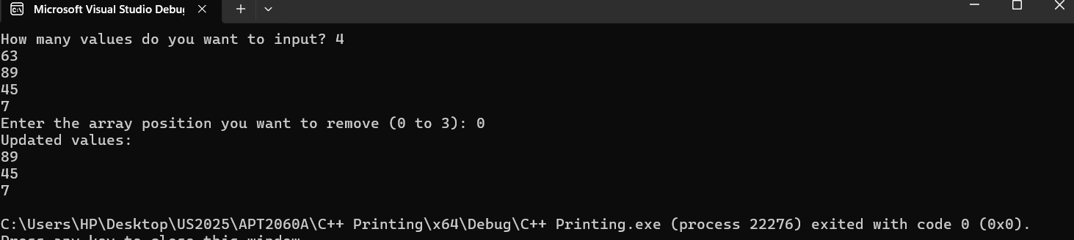
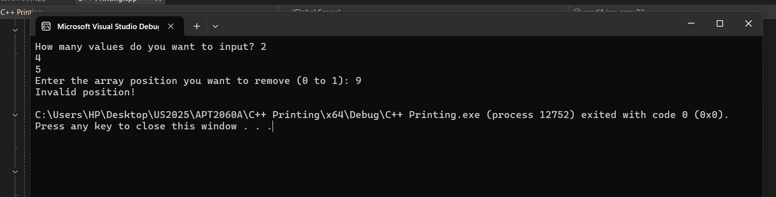
Question 3:
- Using user defined functions and also the main function, write a C++ program for creating an array. The program should also display the values: note- the program should have a function for capturing the value, function for displaying and the main function

Code Segment
#include <iostream>
using namespace std;

//Using user defined functions and also the main function, write a C++ program for //creating an array.
// The program should capture values from the user and display them.

void captureValues(int arr[], int& n) {
cout << "Enter number of values: ";
cin >> n;
cout << "Enter the values:\n";
for (int i = 0; i < n; i++)
cin >> arr[i];
}

// Function for displaying the values

void displayValues(int arr[], int n) {
cout << "The array values are:\n";
for (int i = 0; i < n; i++)
cout << arr[i] << " ";
cout << endl;
}
int main() {
int arr[100], n;
//captureValues(arr, n);
//displayValues(arr, n);
return 0;
}
Code Test
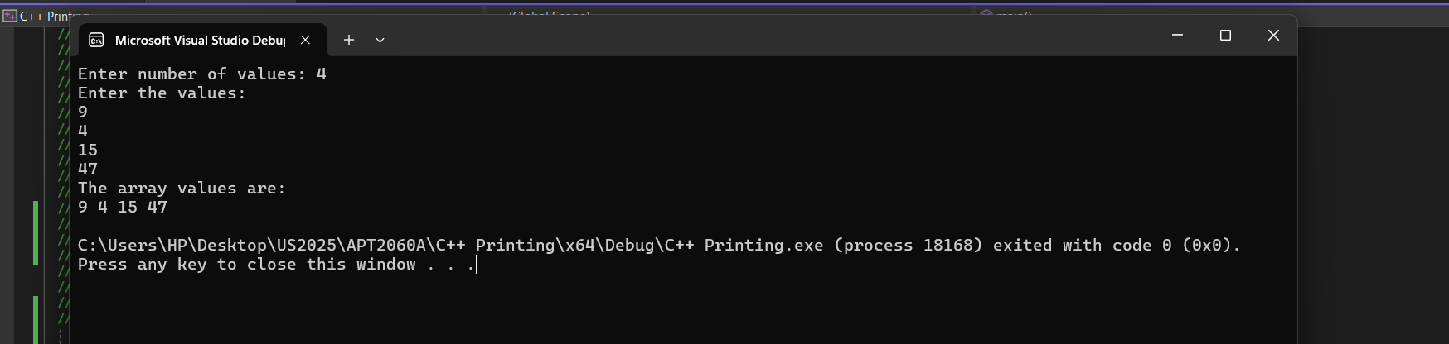

- Write a C++ program that captures employees salary, store the salaries in an array structure. The program should compute the average of the salaries and finally display the employees’ salaries together with deviation from the average (mean). For example, if the salaries are 10,20,30 then the mean (average) is 20 and the results would be
Value Deviation
10 -10
20 0
30 10

Code Segment

#include <iostream>
using namespace std;
void compute_salaryaverage_and_deviation_from_mean() {
double salary[100];
double average, sum = 0; // Initialize 'sum' to 0 to avoid uninitialized memory usage
int employees, i;
double deviation[100];
cout << "Enter the number of employees: ";
cin >> employees;
if (employees <= 0 || employees > 100) {
cout << "Invalid number of employees. Please enter a number between 1 and 100.\n";
return;
}
for (i = 0; i < employees; i++) {
cout << "Enter salary for employee " << (i + 1) << ": \n";
cin >> salary[i];
if (salary[i] < 0) {
cout << "Salary cannot be negative. Please enter a valid salary.\n";
i--; // Decrement i to repeat this iteration
continue; // Skip to the next iteration
}
sum = sum + salary[i];
}
average = sum / employees; // Calculate average salary
for (i = 0; i < employees; i++) {
deviation[i] = (salary[i] - average);
}
// Displaying results
cout << "The average salary is " << average << endl;
cout << "=============================================================\n";
cout << "Employee salary deviation\n";
cout << "=============================================================\n";
for (i = 0; i < employees; i++) {
cout << (i + 1) << ": " << salary[i] << "\t " << deviation[i] << endl;
}
}
Code Test
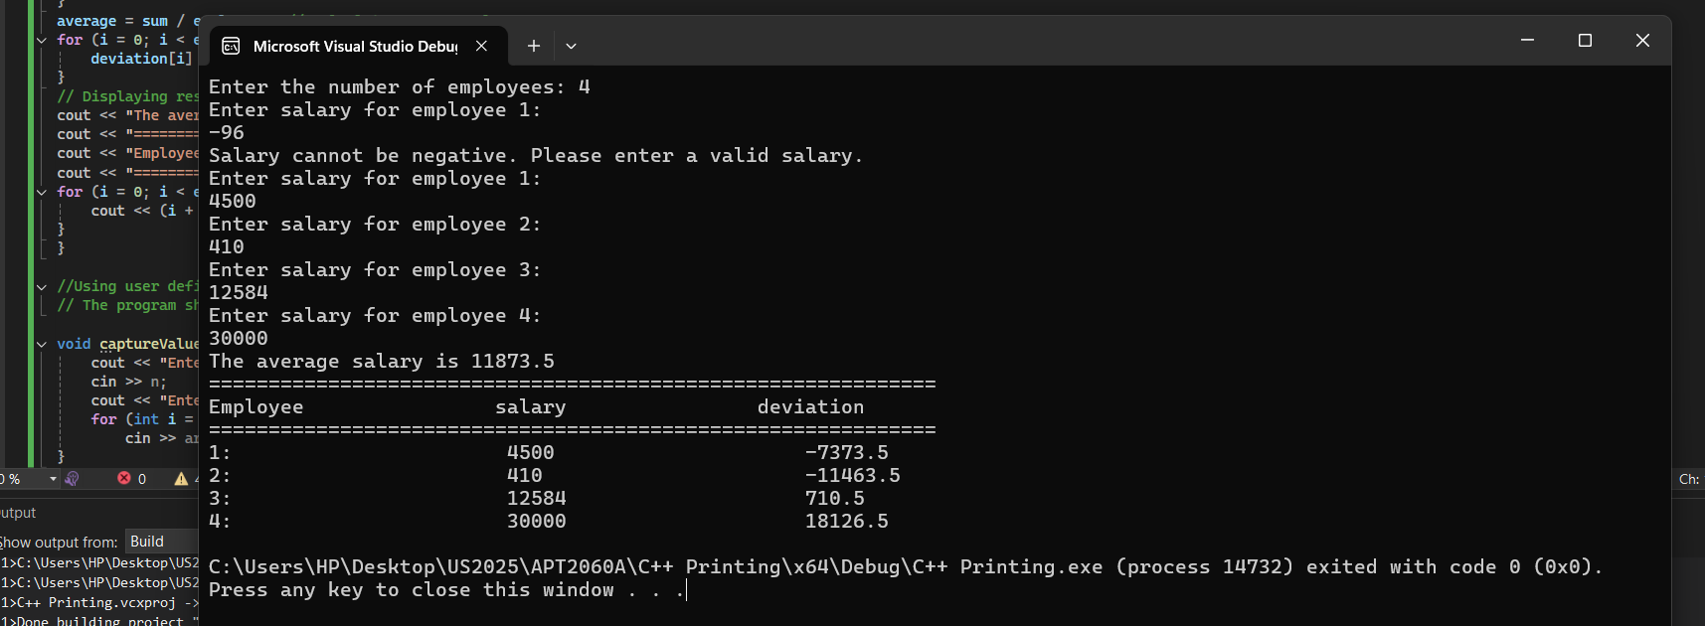
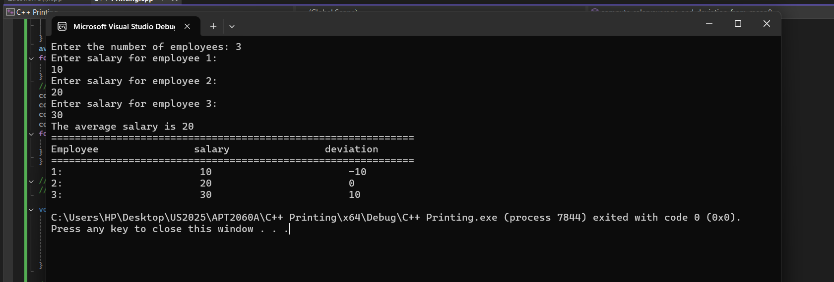
Question 4:
Write a C++ program for performing linear search. The program should have the following user defined functions
Function for capturing the values, function for linear search and the main function

Question 4:
Write a C++ program for performing linear search. The program should have the following user-defined functions:
- Function for capturing the values
- Function for linear search
- The main function

Algorithm for Linear Search:
Step 1: Start
Step 2: Declare an array of size n
Step 3: Input the number of elements (n)
Step 4: Input n values into the array
Step 5: Input the value to search (key)
Step 6: Repeat from i = 0 to n - 1:
- - If arr[i] == key, then return i (position found)
Step 7: If the loop ends and no match is found, return -1 (not found)
Step 8: Display the result
Step 9: Stop

Code Segment
#include <iostream>
using namespace std;
// Function to input values into the array
void getValues(int arr[], int size) {
for(int i = 0; i < size; i++) {
cout << "Enter value " << i + 1 << ": ";
cin >> arr[i];
}
}
// Function to perform linear search
int searchValue(int arr[], int size, int key) {
for(int i = 0; i < size; i++) {
if(arr[i] == key)
return i; // Found
}
return -1; // Not found
}
// Main function
int main() {
int arr[50], n, key;
cout << "How many numbers? ";
cin >> n;
getValues(arr, n);
cout << "Enter number to search: ";
cin >> key;
int pos = searchValue(arr, n, key);
if(pos != -1)
cout << "Number found at position " << pos << endl;
else
cout << "Number not found." << endl;
return 0;
}
Code Test
